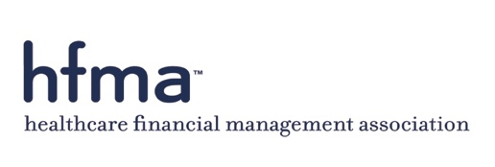

HFMA 2020 OFFICIAL PROXY

SIGNATURE REQUIRED MEMBER ID #

I hereby appoint Marc B. Scher, CPA, Election Validation Committee Chair, Cindy Price, FHFMA and Abby Birch, CRCR each of them proxies of the above-signed, with full power of substitution to vote with the same force and effects as the above-signed could if personally present at the Annual Meeting of Members of the Healthcare Financial Management Association on Monday, April 27, 2020, 11:00 a.m. CST, at the JW Marriott Austin, Texas.

CHECK HERE IF VOTING FOR ALL NOMINATED CANDIDATES. DO NOT make a
mark below.
Or, you may select individuals below by choosing the appropriate boxes.

CHAIR-ELECT (vote for one) (Write-in Candidate)
Aaron R. Crane, FHFMA, CPA, MHA or

SECRETARY/TREASURER (vote for one) (Write-in Candidate)
Dennis E. Dahlen, CHFP, CPA or

DIRECTORS (vote for three) (Write-in Candidate)
Colleen M. Blye, CPA or

Maureen A. Clancy, FACHE, CPC or

Matthew E. Cox, CHFP, CPA or

RETURN VIA FAX TO: (708) 531-0032
ATTN: PRESIDENT’S OFFICE
Please do not use a fax cover sheet.
Alternately, return the completed ballot in the enclosed postage paid envelope.

