Dear HFMA Member,
In this rapidly changing environment HFMA is fully dedicated to leading the financial management of health care. In fact, that’s our mission.
Through your active support and participation in HFMA, you all play an important role in our pursuit of that mission. Now we offer you another opportunity to help lead our changing industry with the enclosed official notice of the Annual Membership Meeting and Proxy Ballot.
The Annual Membership Meeting of HFMA will be held Monday, April 27, 2020, 11:00 a.m. CST at the JW Marriott Austin, Texas. Based on the recommendations of the HFMA Governance Committee, the HFMA Board of Directors has prepared a slate of officers and directors for your consideration as the leadership of the Association for the next year. The Board of Directors recommends that you vote in favor of the entire slate.
Please note your member ID is automatically recorded. Additional meeting information and candidate’s biographies are available at http://www.hfma.org/vote.
Members may also elect to receive printed proxy materials via email: Send a blank email to vote@hfma.org with the word VOTE in the subject line.
All ballots received by Monday, April 20, 2020 will be included in a drawing for Amazon gift certificates.
Thank you for taking the time to cast your vote and for your lasting dedication in helping shape the future of HFMA.
Very truly yours,
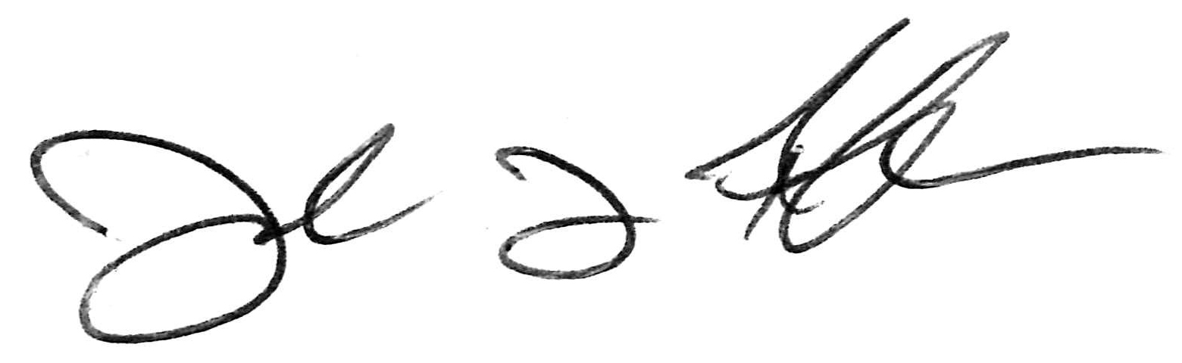
Joseph J. Fifer, FHFMA, CPA
President and CEO

